PhotoSound ADC Hub

Operation Manual, 2021-08-17

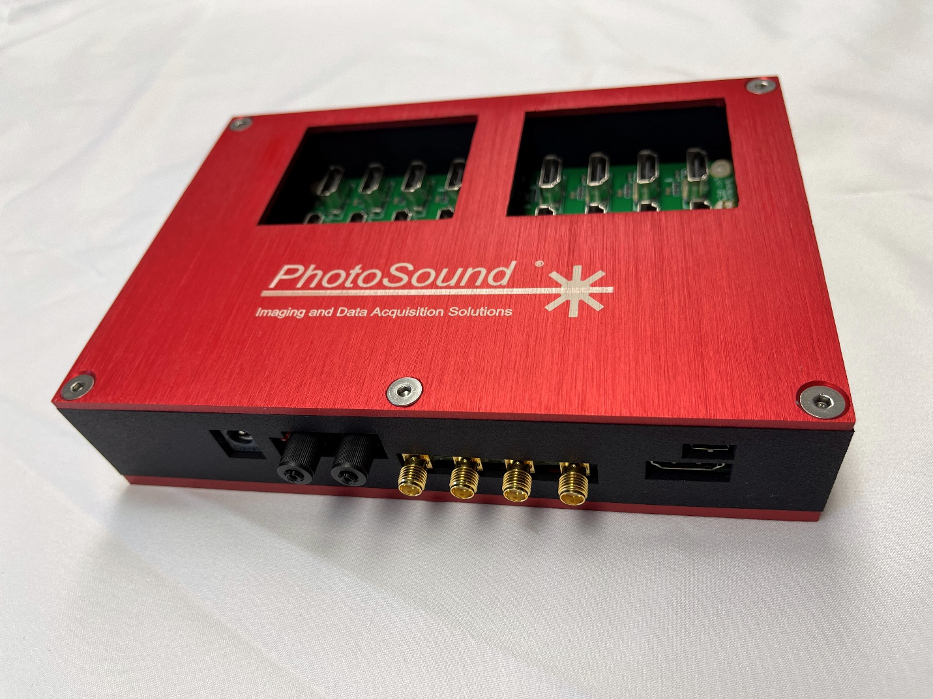

ADC Hub Revision 1.0
This operation manual describes the LEGION ADC Hub Rev1.0. Hardware configurations and a programming guide with the SDK source code description are covered in separate documents. This manual might be changed without notice. This manual cannot be distributed without the explicit permission of PhotoSound.

Table of Contents
Product description 3
LEGION ADC Hub hardware 3
Parts 3
Absolute maximal ratings and recommended operation conditions 3
Hub connectors and indicators 4
Trigger input notes: 6
LEGION ADC Hub setup 7
Setting up software environment: application and SDK installation 8
LEGION HubControl.exe 8
HubControl settings 9
Trigger inputs settings 9
Trigger readout settings 10
Hub connection settings 10
Trigger outputs settings 11

Product description
The LEGION ADC Hub (Hub) is a synchronization device for the LEGION ADC128/256 series of products. Using more than four ADC256 boards chained in series introduces significant trigger delays between the sequential boards. The Hub works around this limitation by synchronizing the triggering of up to 16 ADC256 devices in parallel directly to the Hub via a dedicated HDMI connection per board.
The Hub has a set of trigger inputs equivalent to the trigger inputs of Legion ADC. If the Hub is used with a Legion ADC, it works as a universal master device for all connected Legion ADCs. Only the trigger inputs of the Hub are active. The trigger inputs and HDMI master connectors of the Legion ADCs are NOT used.

LEGION ADC Hub hardware
Note: Section TBD

Parts
Prerequisites typically not included with LEGION products are:
- PC with sufficient number of USB3.0 port(s) and Windows 10 64-bit
- Free MATLAB 9.3 (R2017b) 64-bit runtime.
- Probe with connector matching DAQ probe connectors or breakout board matching preamplifier connectors or cables.
Optional prerequisites are
- Oscilloscope, 2-channel signal generator, and multimeter for testing the board with electrical trigger and verification of the external input trigger signal level.
- Low power CW laser or laser pointer for testing optical trigger inputs without use of high power OPO pulsed laser.

Absolute maximal ratings and recommended operation conditions
Trigger input signal to SMA trigger input
- ≤ 6V to 50 Ω default input impedance setting with jumper(s) installed or
- ≤ 6V to HiZ without jumper(s) installed.
- Measure input impedance on input connectors using multimeter.
- Recommended signal is 4 – 5V, signal duty cycle 1%.

Hub connectors and indicators
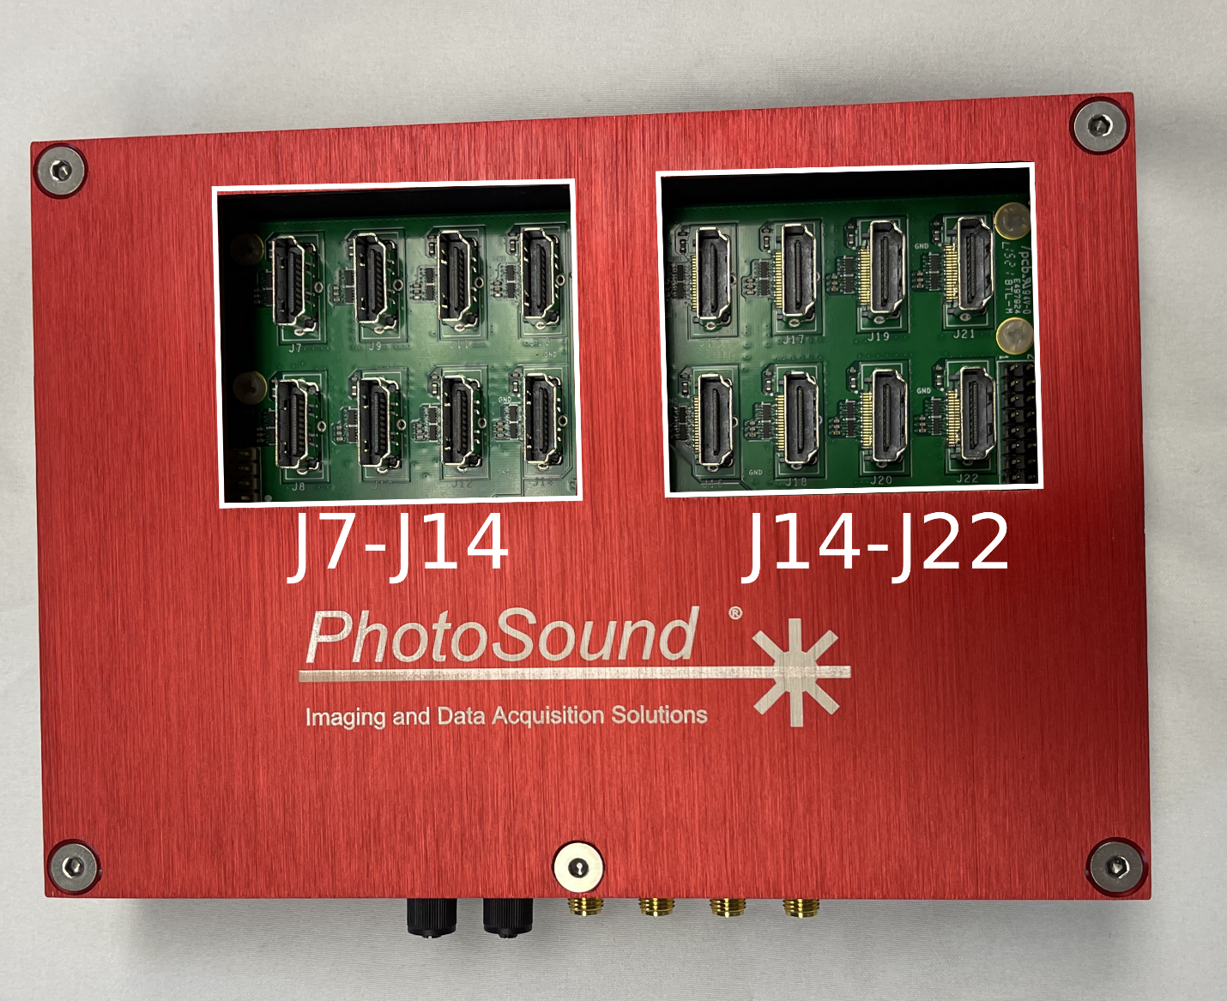
Figure 1: LEGION ADC Hub top. 16 HDMI master (output) connectors (J7-J22) are seen. Use HDMI cable between these master connectors and Legion ADC slave connectors.

Figure 1 and Figure 2 show the Hub’s ports and connectors. These are detailed below:
- HDMI-master connectors – 16 HDMI connectors (J7-J22) that act as the master control for attached ADC256s. Note that the receiving end of the HDMI connection should be attached to the HDMI-slave connection of the ADC256 board.
- DC power connector – 12V 5A power connection port.
- PD1/2 – optical trigger inputs.
- SMA I1/2 – electrical trigger inputs.
- SMA O1/2 – electrical trigger outputs.
- HDMI-slave connector (reserved) – an HDMI port that assigns the Hub as a slave device to a parent Hub device. This connector is reserved for future applications with more than 16 Legion ADCs. Please do NOT use this connector.
- FPGA USB2.0 – USB port that is used to program the trigger settings onto the Hub using the HubControl.exe software (detailed in LEGION HubControl.exe).

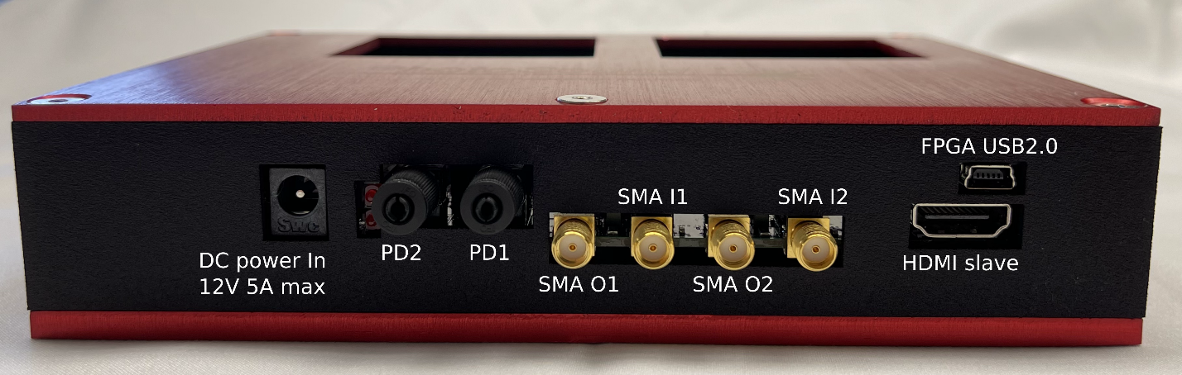
Figure 2: LEGION ADC Hub front view. The optical trigger inputs (PD1, PD2), electrical trigger inputs (SMA I1, SMA I2), and electrical trigger outputs (SMA O1, SMA O2) are shown. The HDMI slave connector (not in use) is reserved for setting the entire Hub as a slave device to a parent Hub device. Do NOT use HDMI slave connector. The USB2.0 connection is for programming the Hub’s board with the HubControl.exe.

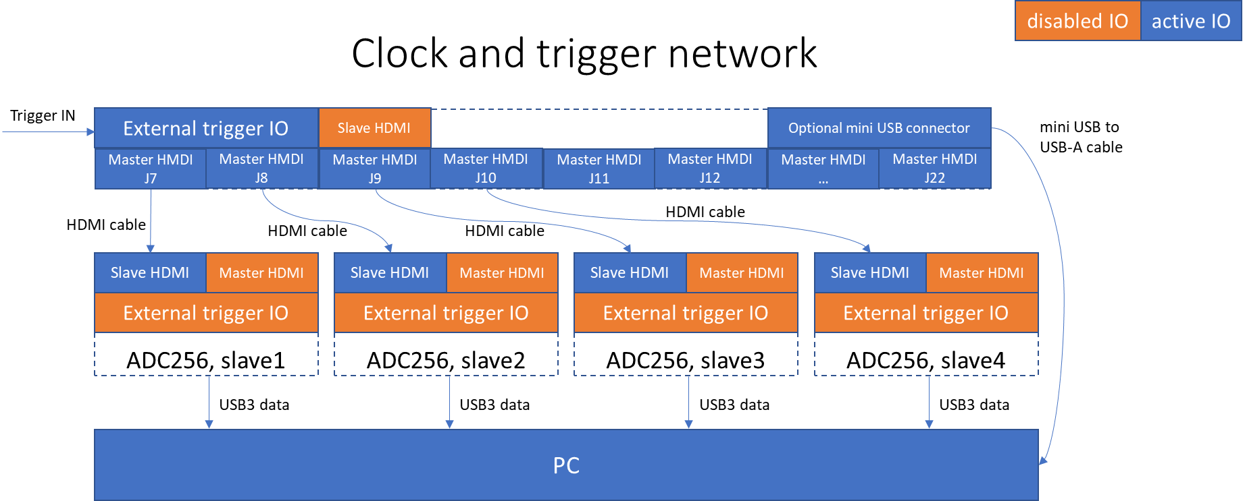
Figure 3: Principle scheme of the clock and trigger network. Up to 16 Legion ADC can be connected to a single Hub. Only 4 ADCs are shown. Power is not shown. External trigger IO are isolated SMA IO and photodiode IO connectors. HDMI cables directionality shows only trigger and clock path. Passive HDMI cables physically are NOT directional and have two identical ends.

Trigger input notes:
- Trigger input source is programmatically selectable between PD1, PD2, J12, J15 or combinations. LEGION board is typically using only single trigger input. Optical trigger PD1 or PD2 are preferred trigger sources.
- If the trigger source is electric applied to SMA J12 or J15, verify input impedance setting on jumpers J13 and J16 accordingly. Input impedance can be also measured using Ohmmeter if the board is not powered.
- Input feed-through 50 Ω terminator can be installed externally to convert HiZ input to 50 Ω input. BROADWAVE TECHNOLOGIES INC. MODEL 851 - 054 – FTT.
- The trigger applied level to SMA trigger inputs must be within 4 – 5.5 V. Verify voltage level applied to this connector using oscilloscope input with 50 Ω (closed jumper) or HiZ (open jumper) setting depending on input impedance jumper position. ATTENTION: 4 – 5 V to 50 Ω load corresponds to 8 – 10 V to HiZ load, which will irreversibly damage the isolator IC (Analog ADCMP605BCPZ). High voltage damage to trigger interface IC is not covered by warranty. If oscilloscope does not have 50 Ω input, use 50 Ω BNC adapter, like Rigol ADP0150BNC or similar.
Isolated trigger output SMA connectors have 5V ±10% output signal and 50 Ω output impedance. The output trigger amplitude is 5 V ±10% to HiZ load and 2.5V ±10% to 50 Ω load. The output can drive 50 Ω load with a low duty cycle and HiZ with any load cycle. Output trigger signal can be programmed using SDK.

LEGION ADC Hub setup
LEGION ADC256 is equipped with FX3 USB3 chip from Cypress Semiconductor and use propitiatory FX3 Cypress driver (see release and copyright notes in the driver folder). The driver is located in \driver folder.
- Connect ADC Hub to PC using a USB 2.0 cable (A-male to mini-B).
- On PC open Device manager and expand Ports (COM & LPT).
- Power ADC Hub using provided 12VDC power supply with 2.1mm barrel connector.
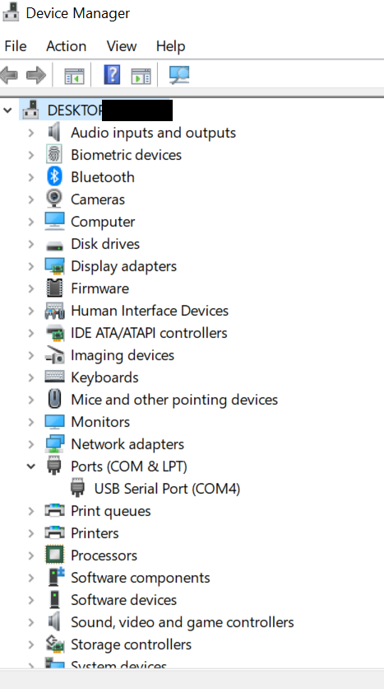
Figure 4: ADC Hub recognition by Windows as comport device.
- Find a new device in Device manager, Figure 4. The windows PC will automatically recognize the device as a comport connection. Note the port number in parenthesis of the device, COM4 in the example case of Figure 4.

Setting up software environment: application and SDK installation
- Install MATLAB 2017b (9.3) Runtime for compiled version only or MATLAB 2017b for source code. Restart computer, if prompted.
- Extract 7zip archive with application software to any folder.
For application software run the HubControl.exe file.

LEGION HubControl.exe
Figure 5: HubControl directory. Includes the HubControl.exe software and a HubControl.exe.config file.

Verify that the directory of the HubControl executable has the accompanying config file (Figure 5).
Run the HubControl.exe software (Figure 6).
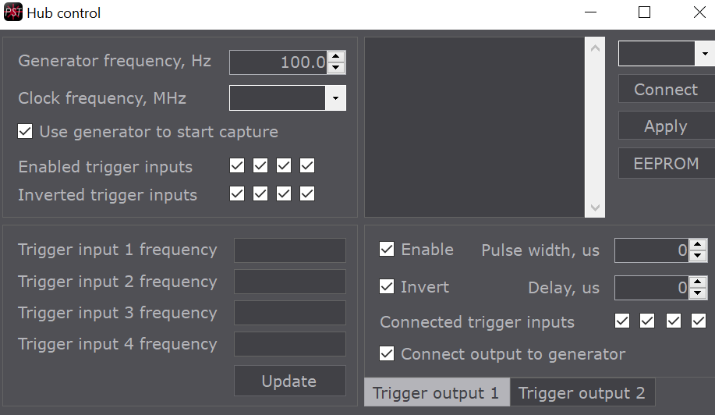
Figure 6: HubControl software. Hub not connected.

Select the dropdown list above the ‘Connect’ button and select the Hub’s comport label that is identified in the setup of the LEGION ADC, then press ‘Connect’. The textbox will show a log of the Hub’s connection status. If there are any errors, contact PST.

HubControl settings
This section will familiarize the user with the HubControl application’s settings parameters.

Trigger inputs settings
The first quadrant (top-left section) of the HubControl software is shown in (Figure 7).
- Generator frequency, Hz – The ADC Hub has an internal generator source. This is mainly used for testing. If activated, this textbox sets the internal generator’s repetition rate in Hz.
- Clock frequency, MHz – The ADC Hub can have variable clock frequencies set by a drop-down list. The Hub’s clock frequency should match the clock frequency of the attached ADC boards, which is default set to 80 MHz.
- Use generator to start capture – checkbox that enables/disables the internal generator as a trigger input source. Unless testing the device without external triggers, disable this setting.
- Enabled trigger inputs – Four checkboxes which set the trigger inputs to enable/disable. The four checkboxes correspond to the following trigger input sources on the Hub: 1st – SMA1 (electrical), 2nd – PD1 (optical), 3rd – SMA2 (electrical), 4th – PD2 (optical).
- Inverted trigger inputs – Four checkboxes which set the trigger input of the Hub at the fall of the input pulse rather than the rise. Checkbox ordering is detailed in (d).
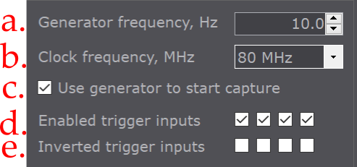
Figure 7: Trigger inputs settings

Trigger readout settings
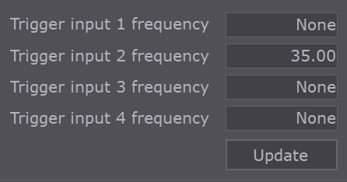
Figure 8: Trigger readout settings.

The trigger readout settings have four display texts, which are ordered top-bottom as: 1st – SMA1 (electrical), 2nd – PD1 (optical), 3rd – SMA2 (electrical), 4th – PD2 (optical). The detected external trigger input will be updated when the ‘Update’ button is pressed. In the example shown (Figure 8) a 35 Hz optical trigger input is detected at PD1.

Hub connection settings
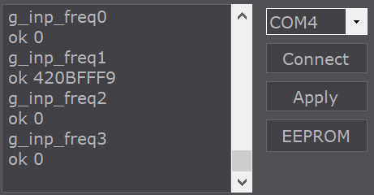
Figure 9: Hub connection settings.

The Hub connection settings quadrant (Upper right) connects the software to the Hub and applies any changed setting in the software to the Hub. The left textbox is a log of the Hub’s get and set functions applied. These functions are listed in TBD.
The dropdown list at the top-right of the quadrant is used to specify the Hub’s comport number, which is found in the device manager, as noted described above.
The ‘Connect’ button will connect the software to the Hub for programming after an appropriate comport label is selected in the dropdown list above.
The ‘Apply’ button will configure any changed setting from the HubControl Trigger inputs settings (Figure 7) and Trigger outputs settings quadrants (Figure 10) onto the Hub’s programming buffer. This button will apply the settings for the session, but these settings will be erased when the Hub is power cycled.
The ‘EEPROM’ button writes the programed settings of the current session that is set by the ‘Apply’ button. The programmed settings are saved onto the Hub’s onboard controller and will be persistent through power cycling the Hub.
Use the ‘Apply’ button to test the trigger settings of the Hub. When satisfied, program the settings onto the Hub with the ‘EEPROM’ button to save the settings onto the Hub’s controller. Once the settings are written onto the Hub’s controller, the USB 2.0 interface is no longer needed for the Hub to repeat the set commands. If a new trigger input/output configuration is necessary, reattach the USB2.0 connection and reprogram the Hub using HubControl.exe. The device must only be powered and have connections to ADC boards in a master(Hub)-slave(ADC) configuration (via HDMI cables) to function.

Trigger outputs settings
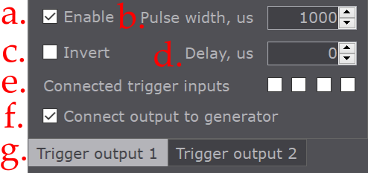
Figure 10: Trigger outputs settings.

The Hub has two electrical trigger outputs. Each output can be enabled to repeat a detected input trigger as well as triggers from the internal generator, when enabled.
- Enable – checkbox that enables/disables the trigger output function for the chosen SMA output. The SMA O1/2 is chosen by selection in (g).
- Pulse width, us – sets the trigger output pulse width in µs.
- Invert – enables/disables the inversion of the trigger output pulse.
- Delay, us – sets the trigger output delay after a trigger input event is detected, in µs.
- Connected trigger inputs – checkboxes that indicate which trigger inputs (SMA I1/2, PD1/2) of the Hub to repeat as the trigger output (SMA O1/2). For the order of the checkboxes, see Trigger inputs settings (d).
- Connect output to generator – checkbox that connects the trigger output to the internal generator of the Hub. Only used for testing, otherwise uncheck this box.
- Trigger output # - user selects which trigger output to modify settings for. Note that both trigger outputs (SMA O1/2) can be enabled at the same time, but each trigger output must be set individually. i.e., Set the trigger output settings for Trigger output 1, then switch to Trigger output 2 and set its settings.

